OFFICE MOVE SAVINGS

SCHNEIDER = £16380 for 13 desks

WW = £9487 for 17 desks

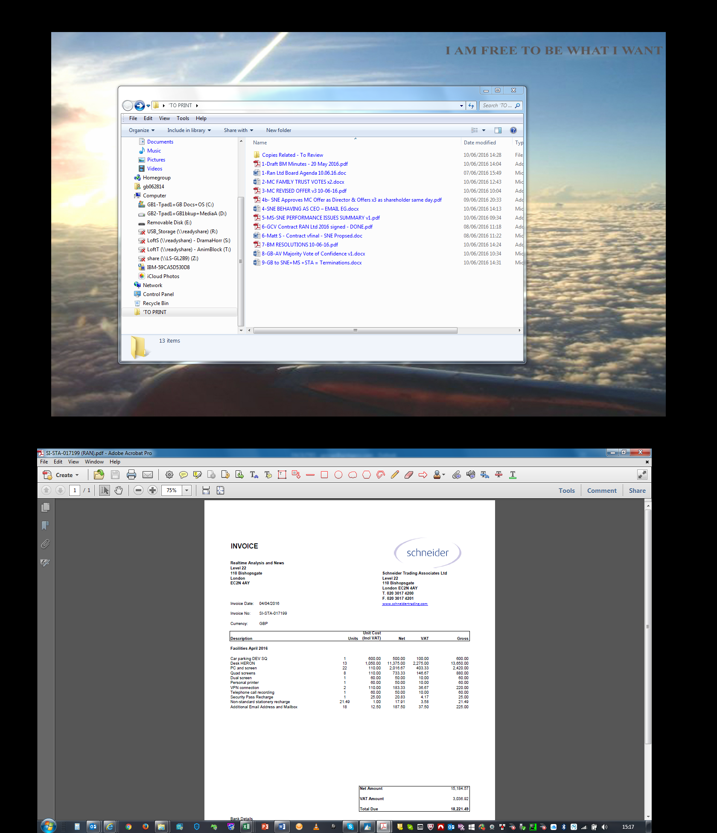

Hi George,

Lovely speaking with you guys just now. Below are the options we viewed on the 1st floor and I have attached a copy of the floorplan of the offices as well:

The total of these offices would come to £12,650/month. I can to offer 25% off and bring this down to **£9,487.5 per month.**

Once the agreement is finalized, I'm happy for your team to move in on Monday and have rest of June as complimentary. I would waive the £60/desk setup fees as well to get your team started ASAP here at Moorgate.

Please let me know if you have any other questions and let's circle back tomorrow on your thoughts.

Looking forward,

Begum

|  |  |
| --- | --- |
| |  | | --- | | **WeWork | Begum Cura** Associate Community Manager | Moorgate, London  [+44 (0) 208 004 1781](tel:%2B44%20%280%29%20208%20004%201781)  [wework.com](http://www.wework.com/)  Create Your Life's Work    *Help grow the WeWork community! For each successful*[*referral*](https://itunes.apple.com/us/app/wework-referral/id966704097?mt=8)*, you'll earn 10% monthly commission for up to a year.* | |

https://mailfoogae.appspot.com/t?sender=aYmVndW0uY3VyYUB3ZXdvcmsuY29t&type=zerocontent&guid=a3dc793e-ba86-4653-b153-b16464b42cdcᐧ